**What is Load Testing?**

Load testing is the process of putting demand or request on a software system or computing device and measuring its response. Load testing is performed to determine a system's behaviour under both normal and load conditions.

**Why Load Testing?**

Load testing is a type of non-functional testing and software testing which is conducted to understand the behaviour of the application under a specific expected load. It is performed to determine a system’s behaviour under both normal and at peak conditions. It helps to identify the maximum operating capacity of an application as well as any bottlenecks and determine which element is causing degradation. E.g. If the number of users are increased then how much CPU, memory will be consumed, what is the network and bandwidth response time.

**Performance Testing**

Performance testing is testing that is performed to determine how fast some aspect of a system performs under a particular workload. It can compare two systems to find which performs better. Or it can measure what part of the system or workload causes the system to perform badly.

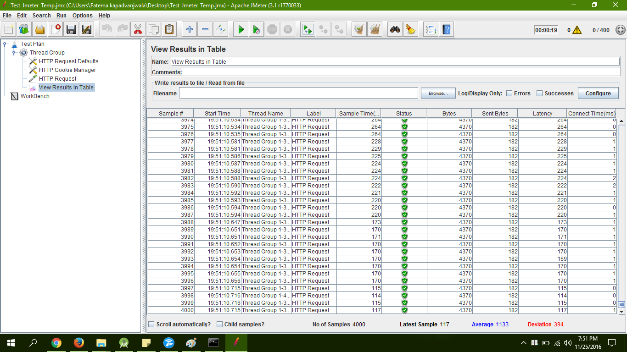

**Stress testing**

Stress testing is the process of determining the ability of a computer, network, program or device to maintain a certain level of effectiveness under unfavorable conditions. The process can involve quantitative tests done in a lab, such as measuring the frequency of errors or system crashes.

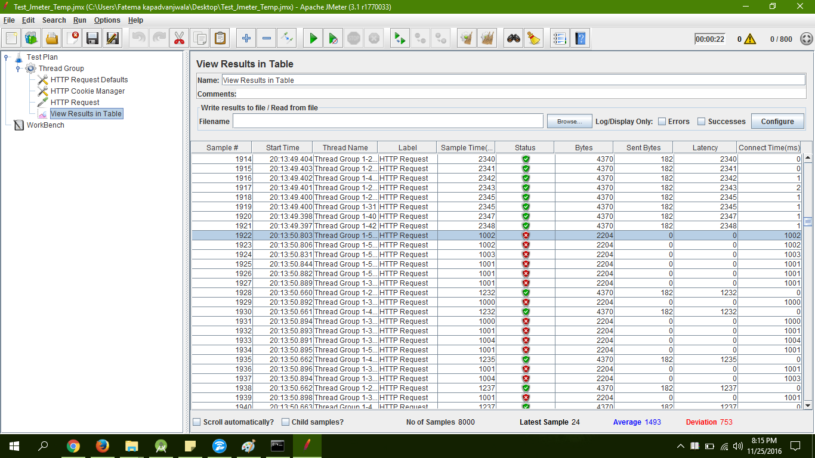

**Load testing using JMeter**

Login Module: - Stress Testing



Login Module:- Performance Testing



|  |  |
| --- | --- |
| No. of Threads | Result |
| 400 | Success |
| 800 | Failure |

Register Module: - Stress Testing

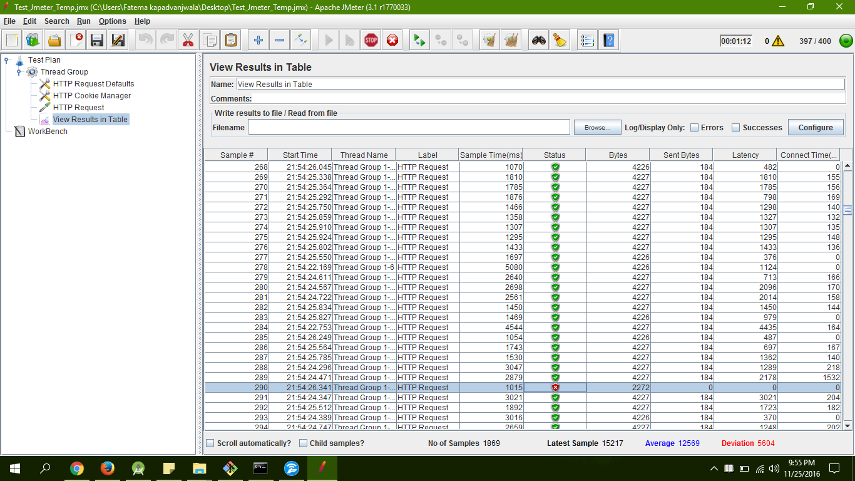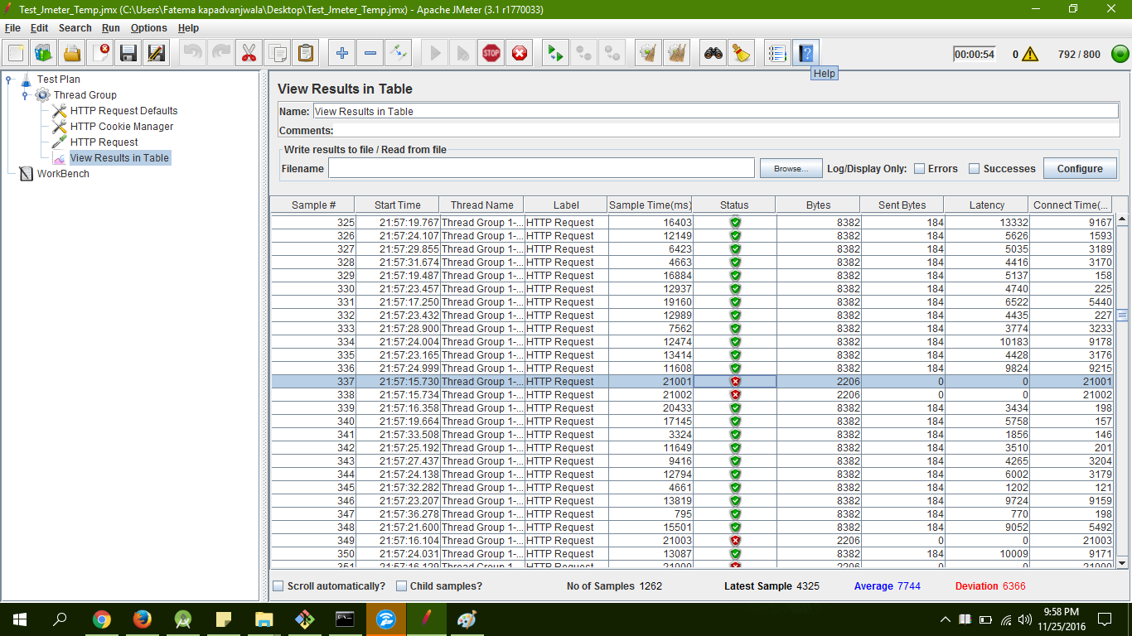

|  |  |
| --- | --- |
| No. of Threads | Result |
| 400 | Success |
| 800 | Failure |